LINUX PROGRAMMING
SWE4009
NAME: ANJANA P
REG NO.: 17MIS1028

1.)

SHELL SCRIPT:
if ls| grep -E '%|\$|@|!|~|#|\^|&|\*'!=0; then
echo "Error - File with special characters exist!!!"
fi
rm `ls| grep -E '%|\$|@|!|~|#|\^|&|\*'`

SCREENSHOT:

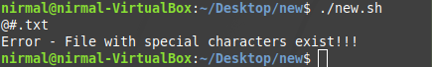

2.)

SHELL SCRIPT:
echo "This is the message body" | mutt -a "email.txt" -s "subject of message" -- nirmalmalaivasan@gmail.com

SCREENSHOT:

